**COMET BAY COLLEGE**

**Physics Unit 3 - Task 5**

**Electromagnetism Test 1**

**Name: SOLUTION Total Marks /53**

**All questions must be answered and to WACE specifications**

**Question 1**

A force of 8.50 × 10-3 N attraction is felt between two charged spheres that are 45 cm apart.

1. If one has a charge of + 0.3 μC, what is the charge on the other (2 marks)

**F =**

**8.5 × 10-3 =**

**q2 = (1 mark)**

**q2 = 6.38 × 10-7 C (1 mark)**

**as it is an attraction then q2 = − 6.375 x 10-7 C (1 mark)**

1. The two spheres are then forced together (and touching) and allowed to separate to a distance of 30 cm apart. What is the force between the two spheres now? (5 marks)

**Touching means the two spheres evenly**

**distribute their charge (1 mark concept)**

**Charge on each sphere = $\frac{+0.3+(-0.638)}{2}$**

**= − 0.169μC (1 mark)**

**(Note − 6.38 x 10-7 C = − 0.638 μC)**

**F =**

**F = (1 mark)**

**F = 1.81 × 10-2 N (1 mark)**

**repulsion (1 mark)**

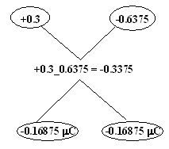

**Question 2**

Two identical magnets are fixed in position on a flat bench. A compass is placed near the magnets.

1. Sketch the magnetic field in the region around the magnets. Draw at least 4 field lines for each magnet. (2 marks)



**N S**

**N**

**S**

Compass

1. Indicate the direction that the compass needle will point by placing an arrow in the circle. (1 marks)

**Aligns with vector addition of 2 component fields.**

🞫 🞫 🞫 🞫

🞫 🞫 🞫 🞫

🞫 🞫 🞫 🞫

🞫 🞫 🞫 🞫

🞫 🞫 🞫 🞫

Rail falling at 25.0 m/s within magnetic field

**Question 3**

An iron rail of mass 150 kg and length 4.22 m is falling at 25.0 m s-1 next to a magnetic pole of a large electro-magnet in a breakers yard. The magnetic flux density of the electro-magnet is 840 mT and its direction is indicated in the diagram.

1. Calculate the potential difference across the length of the rail. (2 marks)

**l = 4.22 m v = 25.0 m/s B = 0.840 T**

**emf = lvB = 4.22 x 25.0 x 0.840 (1 mark)**

**emf = 88.6 V (1 mark)**

1. Explain, referring to charge location, how a potential difference is established in this situation. (2 marks)

**Electrons are forced to the left hand side of the rail. (1 mark)**

**This establishes a region of negative charge at the left and a region of positive charge at the right. (1 mark)**

**Question 4**

Students construct a model electric heater in the laboratory using two lengths of nichrome wire as heating elements. The two wires have resistances of 10.0 Ω and 20.0 Ω respectively.

1. Calculate the current that would flow through each wire and the power that will be produced by the model heater if they are connected in **series** with each other and a 12 V battery is used to complete the circuit. (4 marks)

**V = 12 V**

**R = (10 + 20) = 30 Ω (1 mark)**

**V = I R**

**12 = I x 30 (1 mark)**

**I = 12/30**

**Current in the resistors is 0.4 A (1 mark)**

**P = I2 R**

**P = 0.42 x 30**

**Power produced = 4.8 W (1 mark)**

1. If the two lengths of nichrome wire were then connected in **parallel** with the 12 V battery, calculate the current that would flow through each wire and the total power produced. (6 marks)

**V = 12 V**

**1/R = 1/10 + 1/20 = 3/20 (1 mark)**

**so R = 6.67 Ω**

**V = I R**

**12 = I x 6.67 (1 mark)**

**I = 12/6.67**

**Total current in the circuit is 1.8 A (1 mark)**

**Current is divided according to the 10:20 ⇒ 2:1 (1 mark concept)**

**Current in 10 Ω wire is 1.2 A**

**Current in 20 Ω wire is 0.6 A**

**P = I2 R**

**P = 1.82 x 6.67 (1 mark)**

**Total power produced is 21.6 W (1 mark)**

**Question 5**

An apparatus used for identifying minerals in mining samples involves releasing electrons from a cathode electron gun and accelerating them across a potential difference and through a pair of parallel charged plates and then impacting with the sample. The electrons are accelerated through a potential of 35 kV, and through a distance of 330 mm between the charged plates.



1. Calculate the strength of the electric field between the charged plates. (2 marks)

**potential = 35 kV**

**distance between plates = 330 mm**

**charge on electron = -1.6 x 10-19 C**

**mass of electron =9.11 x 10-31 kg**

**magnetic field strength = 0.300 T**

**Electric field strength = V/d**

**Electric field strength = 35 x 103 / 0.33 (1 mark)**

**Electric field strength = 1.06 x 105 N C-1 (1 mark)**

1. Calculate the magnitude of the velocity of the electrons as they exit the electron gun assembly. (4 marks)

**Energy = W = q V**

**Energy = (-1.6 x 10-19) x 35 x 103 (1 mark)**

**Energy = 56 x 10-16 J**

**Energy = KE = ½ m v2 (1 mark concept)**

**(56 x 10-16) = ½ (9.11 x 10-31) x v2 (1 mark)**

**v2 = (56 x 10-16) x 2 / (9.11 x 10-31) = 122.9 x 1014**

**v = 1.11 x 108 m s-1 (1 mark)**

1. After leaving the electron gun assembly, the electrons travel through a uniform magnetic field which is perpendicular to their direction of motion. If the magnetic field strength is 0.300T, through what radius will the electrons be deviated? (2 marks)

**F = qvB = m v2/r**

**q B = m v/r so r = m v / q B**

**r = (9.11 x 10-31) x (1.11 x 108) / (1.60 x 10-19) x 0.300 (1 mark)**

**r = 0.0021 x 10-3 m (1 mark)**

**Question 6**

Steve is demonstrating that a 7.00 kg bucket full of water can undergo vertical circular motion upside down without the water falling out. He is spinning the bucket around on the end of a rope to give a radius of 1.20 m. At the top of the circle the bucket has a speed of 4.00 m s-1

1. Calculate the tension in the rope for the instant shown. Draw a vector diagram.

(4 marks)

Weight

sum of forces

Tension



Bucket of water

**By analysing forces acting on the bucket (1 mark)**

**∑F = W + T**

**mv2/r = mg + T**

**T = mv2/r - mg (1 mark concept)**

**T = (7 × 42 )/ 1.20 - (7×9.8) (1 mark)**

**T = 24.7 N (1 mark)**

1. Explain why the water does not fall out of the bucket. (1 mark)

**The bucket and water are in circular motion and both are being accelerated to the centre of the circle (1 mark)**

**Or similar**

**As long as speed is high enough that an action force from mass of water is applied to base of bucket then it will not drop out of circular motion**

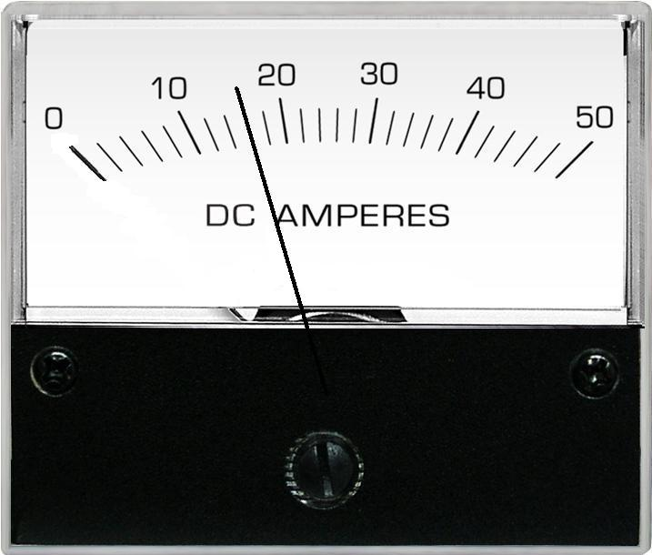**Question 7**

The meter to the left was used during an experiment.

1. What does the meter measure? (1 mark)

**Current (1 mark)**

1. What is the value recorded on the meter? (1 mark)

**16 (1 mark)**

1. What is the uncertainty? (1 mark)

**± 1 (1 mark)**

**Question 8**

1. The diagram at right shows a permanent magnet and a wire carrying current.

(2 marks)

1. Sketch 6 lines to indicate the field of the magnet.

**Field lines (1 mark)**

**S N**

⦿

1. Indicate on the diagram the direction of magnetic force acting on the wire with an arrow labelled “force”.

**Force (1 mark)**

1. The diagram at right shows a cross section of a powered solenoid. The magnetic polarity at each end of the solenoid is shown. (2 marks)
2. Shown on the diagram, the direction of current that will establish this field.

**Current into page**

**N**

**S**

1. Sketch 3 magnetic field lines within the solenoid core.

**Current out of page**

**Question 9**

Some university students are investigating the circular magnetic field formed around a long straight wire carrying electrical current. They use a probe that measures magnetic flux density at different radii of separation from the wire.

Separation between meter and wire

Probe that measures magnetic flux density

⦿

Current carrying wire

The students know that the magnetic flux density decreases with increasing distance from the wire.

The students put a 90 cm straight length of wire between two clamps such that no objects (other than the probe) are closer than 40 cm to the centre of the wire.

A steady current of 2200 A is fed into the wire from an external power supply.

The probe that measures magnetic flux density is placed at set distances from the middle of the wire and measurements recorded.

The students analyse the difficulty obtaining a precise measurement of magnetic flux density and decide to record this data with an uncertainty of ±7%.

The magnetic flux density B, due to a current I, passing in a wire is given by the expression:

$$B= \frac{μ_{0}I}{2πr}$$

The results obtained are as follows:

|  |  |  |
| --- | --- | --- |
| **Radius of separation**  **(m)** | **1/r**  **(m-1)** | **Magnetic Flux Density**  **(x 10-3 T)** |
| 0.065 | 15.4 | 6.70 ± 0.47 |
| 0.080 | **12.5** | 5.90 **± 0.41** |
| 0.100 | **10.0** | 4.50 **± 0.32** |
| 0.125 | **8.0** | 3.50 **± 0.25** |
| 0.200 | **5.0** | 2.10 **± 0.15** |
| 0.500 | **2.0** | 0.90 ± 0.06 |

|  |  |  |
| --- | --- | --- |
| **Radius of separation**  **(m)** | **1/r**  **(m-1)** | **Magnetic Flux Density**  **(x 10-3 T)** |
| 0.065 | 15.4 | 6.70 ± 0.47 |
| 0.080 |  | 5.90 |
| 0.100 |  | 4.50 |
| 0.125 |  | 3.50 |
| 0.200 |  | 2.10 |
| 0.500 |  | 0.90 ± 0.06 |

Answer the following questions:

1. Complete the second column of the table $\frac{1}{r}$, so that you can plot a straight line graph. One value has been done for you. (1 mark)

**As table values (1 mark)**

1. Complete the third column of the table **(Magnetic Flux Density)** to include the uncertainty for each measurement. Two values have been done for you. (1 mark)

**As table values (1 mark)**

1. Plot a graph of Magnetic Flux Density (B) on the vertical axis versus $\frac{1}{r}$ on the horizontal axis. You must include a line of best fit and error bars. (6 marks)

C:\Documents and Settings\Peter\My Documents\Physics\PG Documents\Year 11 Physics\7. Y11 Exams\2009 S2\Sec C 8 by 7 line weight 25 and 4.emf

Axes labels ✓

Axes units ✓

Axes Scaling ✓

Accurate plotting ✓

Line of best fit ✓

Error bars ✓

1. Calculate the gradient of your line of best fit from your graph showing all working.

(3)

Clearly show rise and run construction lines on the graph✓

gradient = 0.0052/11.8 ✓ = 4.41 x 10-4 T m ✓

1. Determine the value of $μ_{0}$, the permeability of free space, from the value of the gradient that you obtained. (If you could not determine the gradient use the numerical value 4.40 x 10-4).

(3)

= 4.40 x 10-4 I = 2200 A

$$μ_{0}=\frac{4.40 x {10}^{-4}×2π}{2200}=1.26 ×{10}^{-6}$$

1. Describe a possible source of experimental error in this experiment.

(2)

For example

The Earth’s magnetic field could be adding to the circular field being measured causing a systematic error. ✓ ✓

Or other valid point.

**Question 10 (7 marks)**

An uncharged flake of metal is stripped of 9.57 million electrons and fed into the space between two horizontal plates set 35.0 mm apart. The plates are charged by a source of emf that establishes an electric field strength of 6.40 🞩 104 N C-1 in the space. The metal flake is seen to rise up in the space between the plates.

Metal flake

Source of emf

Charged plate

Charged plate

35 mm

Negative

Negative

Positive

Positive

1. Indicate on the diagram the polarity of the source of emf, the charge polarity on each plate and sketch at least five field lines for the uniform electric field.

Polarities ✓ Field Lines ✓

(2)

1. Calculate the magnitude of the potential difference across the parallel plates.

E = 6.40 🞩 104 N C-1 (V m-1) d = 0.035 m

E = V / d

V = E 🞩 d = 6.40 🞩 104 🞩 0.035

V = 2240 V

(2)

1. Calculate the magnitude of the electric force acting on the metal flake.

(3)

q = 9.57 🞩 106 🞩 1.60 🞩 10-19 = 1.53 🞩 10-12 C ✓

E = F / q

F = E 🞩 q

F = 6.40 🞩 104 🞩 1.53 🞩 10-12 ✓

F = 9.80 🞩 10-8 N ✓

**Question 11**

A sodium ion with a single positive charge and a mass of mass 3.82 x 10-26 kg enters a uniform magnetic field of flux density 0.258 T at a speed of 1.99 x 105 m s-1 as shown in the diagram below.

* 🞫 🞫 🞫 🞫
* 🞫 🞫 🞫 🞫
* 🞫 🞫 🞫 🞫
* 🞫 🞫 🞫 🞫

Sodium (Na+) ion enters at 1.99 x 105 m s-1

Deflection path

1. Calculate the magnetic force acting on the sodium ion.

(2)

F = qvB

F = 1.60 x 10-19 x 1.99 x 105 x 0.258

F = 8.21 x 10-15 N ✓

1. Sketch an arrow on the diagram and label it “deflection” to indicate which direction the sodium ion will be deflected.

(1)

Shows path ✓

1. Calculate the radius of the deflected path.

(3)

qvB = mv2 / r concept ✓

r = mv / Bq

r = (3.82 x 10-26 x 1.99 x 105) / (0.258 x 1.60 x 10-19) ✓

r = 0.184 m ✓